FOR IMMEDIATE RELEASE
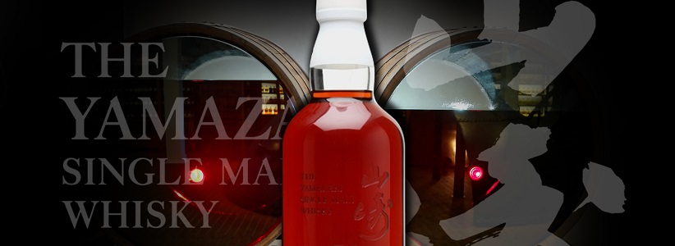
World’s Most Expensive Whisky Bottle Just a Click Away
TOKYO --- 25 April 2017 – The Yamazaki 50 year old, which broke records for the most expensive standard whisky bottle sold at auction late last year, is now in stock online only at dekantā.com. Stock is limited to one bottle. Yes, you heard us.
1961: The East German authorities started building the Berlin wall; Yuri Gagarin became the first human in space; and the USSR tested the most powerful nuclear weapon ever detonated. As dramatic as it was at the time, the Iron Curtain is textbook history, we’re not all living on the moon and neither are we sealed in an underground bunker. This isn’t the first time the state of the world has seemed on the brink of enormous change.

1961 was also the year the Yamazaki 50 year old was sealed in superior Japanese Mizunara oak, not to be opened for another five decades. When the first edition was released in 2005, to great anticipation, its US$9,500 price tag looked pretty steep. Yet, the cost of the first release was only 8.6% of its new record auction price. Editions released of this whisky have consistently sold out within 48 hours of release.

A first edition Yamazaki 50 year old claimed a Guinness World Record for the most expensive standard-format bottle in the history of time when a bottle was sold at a Hong Kong spirits auction for HK$1.003m (US$129,186) last October. The foremost retailer for high end Japanese spirits, dekantā have announced a single bottle of Yamazaki 50 year old single malt is currently available for worldwide delivery from their online store for US$119,999.99. With only 150 bottles ever released, this expression is an extremely rare find.

Presented in an elegant and distinctive box, the Yamazaki 50 year old is an exceptional whisky, representing more than half a century of barrel ageing in just one bottle. At over US$4,286 a dram, this is as decadent a drinking experience as they get.

Tasting notes offered by Suntory describe a whisky that offers “sweet-sour dried fruits, a full-bodied, silky mouthfeel, and a lingering, slightly smoky aftertaste with mild woodiness.” Quite an exceptional dram, and one that very few can claim to have tasted! A single bottle is available at dekantā, so Japanese whisky enthusiasts will need to be quick if they want to get their hands on this most exclusive of bottles.

Notes to Editors:
dekantā Founder Makiyo Masa is available for interview. Please RSVP to arrange, Miriam Rune: miriam@dekanta.com / 07740 339 628.
About dekantā
dekantā offers customers access to the world’s largest online selection of authentic Japanese Spirits and has delivered to 127 countries across every continent in the world. A family owned and run business, dekantā's founders have been selling collectibles since 1985 and specialize in rare, collectible, and new release single malt Japanese whisky. dekantā offers worldwide delivery on an extensive range of Japanese single malt whisky, Japanese grain whisky and Japanese blended whisky, in addition to Scottish whisky released for the Japanese market only.

Consumers who would like to learn more about Japanese whisky should visit the dekantā website, which boasts the most extensive repository of information dedicated to Japanese whisky, including distillery history and tasting notes for each bottle. Bilingual concierge service is available 24 hours a day, providing expert recommendations in both English and Japanese.

About Yamazaki distillery
Founded in 1923 by Master Distiller Shinjiro Torii, the founder of Suntory, Yamazaki is Japan’s oldest commercial whisky distillery. For the first 10 years of operation, Yamazaki was managed by the legendary Masataka Taketsuru, the ‘Father of Japanese Whisky’ and founder of Nikka Whisky. It is held in high regard for the quality of the local water, which was named by Japan’s Ministry of the Environment as one of the best mineral sources available in Japan.
dekanta.com
Follow dekantā on Twitter: @dekantawhisky
Like dekantā on Facebook: facebook.com/dekantawhisky/
High Resolution Press Images (Yamazaki 50): https://goo.gl/AvMTc6
Further High Resolution Press Images: http://press.dekanta.com/

