FOR IMMEDIATE RELEASE TUES 29/11/16
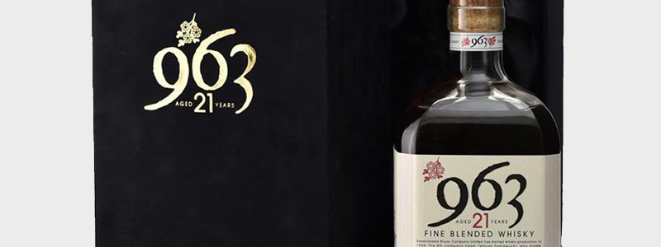
International Premiere for Yamazakura's Premium Japanese Whisky
Discerning whisky drinkers can look forward to finding a rare gem under the Christmas tree this year, as 21-year-old Yamazakura 963 is offered for sale for the first time outside of Japan. This top-tier blended whisky of the celebrated Sasanokawa Shuzo distillery is available in just a handful of shops in its country of origin and online only at dekantā - the world’s largest online store for high-end Japanese spirits.
The Yamazakura 963 is meticulously blended using a combination of single malt and grain whisky and has been praised for its mellow fragrance and complex flavour. Instead of making a long trip to source a rare gift, international whisky connoisseurs can order this highly sought bottle online from Japanese whisky retailer dekantā and receive their purchase in 3-10 days.
Arriving beautifully gift-wrapped in the Japanese style, dekantā's bottles make unique gifts for Christmas. With their wide selection and worldwide delivery, dekantā offers consumers across the globe the opportunity to savour a rare and distinctive Japanese whisky, whether as part of a relaxing evening, or over dinner with friends and family.
Japanese whisky has recently experienced exponential worldwide sales growth, attracting international attention and awards. Distilled in a similar manner to Scotch, Japanese whisky-making processes are refined to better appeal to the local palate. Non-Japanese drinkers often describe the experience of sampling more sophisticated Japanese whiskies as exotic and seductive.
Consumers who would like to learn more about Japanese whisky should visit the dekantā website, which boasts the most extensive repository of information dedicated to Japanese whisky, including distillery history and tasting notes for each bottle. Bilingual concierge service is available 24 hours a day, providing expert recommendations in both English and Japanese.
Read more about the Yamazakura 963 21-year-old on the dekantā website.
Notes to Editors:
dekantā Founder Makiyo Masa is available for interview. Please RSVP to arrange, Miriam Rune: mim@miriamrune.co.uk / 07740 339 628.
About dekantā
A family owned and run business, dekantā's founders have been selling collectibles since 1985 and specialize in rare, collectible, and new release single malt Japanese whisky. As well as Japanese grain whisky and Japanese blended whisky, dekantā offer an extensive range of Scottish whisky released for the Japanese market only.
Stocking rare bottles not available through traditional global distribution channels, dekantā offer world-leading Japanese whiskies to an international market. With a selection of more than 1000 bottles, ranging in price from £30 to £100,000; dekantā presents options for both the avid collector and those new to Japanese whisky.
About Sasanokawa Shuzo Distillery
Originally a producer of sake and shochu founded in 1765, Sasanokawa Shuzo Company Limited turned their hand to whisky production in 1946. They were soon able to compete with large whisky-producing rivals such as Nikka and Suntory, producing fine whiskies of renown.
For more information about the Yamazakura 963 21-year-old and the wide selection of rare and collectible Japanese whiskies available from dekantā, visit https://dekanta.com/.
Follow dekantā on Twitter: @dekantawhisky
Like dekantā on Facebook: facebook.com/dekantawhisky/
High Resolution Press Images: http://press.dekanta.com/
###

